UNIVERSITI TUNKU ABDUL RAHMAN

ACADEMIC YEAR 2020/2021

MAY 2020 TRIMESTER

FINAL ASSESSMENT

UEEN2013/ UEEN2423 TCP/IP NETWORK FUNDAMENTALS

MONDAY, 28 SEPTEMBER 2020 TIME : 1.30 PM – 5.00 PM (3.5 HOURS)

BACHELOR OF SCIENCE (HONOURS) SOFTWARE ENGINEERING
BACHELOR OF ENGINEERING (HONOURS) ELECTRONICS
(COMPUTER NETWORKING)

Instructions to Candidates:

REMINDER: You are reminded to read and adhere to the Final Assessment Instructions to Candidates that has been made available through the UTAR Portal before the commencement of Final Assessment (FA). The detailed instructions for this FA are as follows:

General

- This Final Assessment (FA) is an individual, time restricted assessment which consists of FOUR (4) questions. Each question carries 25 marks.

- You are required to answer ALL questions, and submit the ANSWER SCRIPT by 5.00 PM, 28 SEPTEMBER 2020.

- During the period of 3.5 hours of this FA, the examiner(s) can be reached at
  - [Microsoft Teams] with Code: yvo72zv, or
  - Email:[kckhor@utar.edu.my]
You may use the above e-platform(s) to check with the examiner(s) if you need any clarification on this FA question paper.

- Candidates are reminded that Copy-and-Paste, Consultation, Discussion and Sharing of Answers with others are STRICTLY PROHIBITED in this FA.

Answer Script File

- The answer script MUST be a Microsoft Word file in A4 size format. Note: Please keep the file size NOT exceeding 30MB per file.

- Please check your Index Number generated by the Division of Examinations, Awards, and Scholarships (DEAS). You MUST name your answer script file using the following file name for submission:
[UEEN2013/2423]_FA_[SE/ET]_[Your Index Number]

For example, if you are from the degree programme SE, and your Index Number is A99999CBIBF, then your answer script should be named as:
UEEN2013_ FA_ SE_A99999CBIBF.doc

Answer Script File Submission

- Your answer script file has to be submitted to the following platform(s) before the due time/date.
  - Attach your answer script at WBLE
  - Send your answer script to UEEN2013.LKCFES@utar.edu.my (for SE students) and UEEN2423.LKCFES@utar.edu.my (for ET students)
Note: For the subject / title of your email, use the file name of your answer script, i.e.,
[UEEN2013/2423]_FA_[SE/ET]_[Your Index Number]

- Please make sure you submit the correct, complete and final version of your answer script and the same copy of answer script file is to be submitted to the above platform(s).

Contents of Answer Script

- The first page of your submission is the Final Assessment Cover Page. You MUST use the template given and fill in the following information
  - Your Programme (Abbreviation)
  - Your Index Number
  - Your Name
  - Your Student ID

- The second page of your submission is the Final Assessment Declaration Statement. You MUST use the template given, and digitally sign on the form to indicate the authenticity of your submitted work is without plagiarism.

- Each question should be answered starting on a new page.

- For answer scripts that have text-based answers only, all texts MUST be typed and recommended using Times New Roman characters with font size [e.g. 12], with proper spacing and alignment, except for the drawings and equations/calculations.

- For answer scripts that require / contain drawings, equations and calculations with short text descriptions, please them in the word document as well.

- Please include a page number on each and every page of your answer script. Ensure that each page of answer scripts is in sequence prior to online submission.

WARNING OF PLAGIARISM

- Answer scripts shall be uploaded to Turnitin to check for the originality of submitted answers. In the case of suspected plagiarism, the evidence will be submitted to the Examination Disciplinary Committee of the University. Disciplinary action shall be taken against any candidate who is found to have plagiarized in the answer submitted. Hence, candidates are reminded to abide by all University Rules and Regulations and any instructions/guidelines relating to examinations/assessments.

Answer ALL FOUR (4) questions.

Q1. (a) Transform the following OSI model into a 5-layer TCP/IP model. Draw a diagram to help your answer. (5 marks)
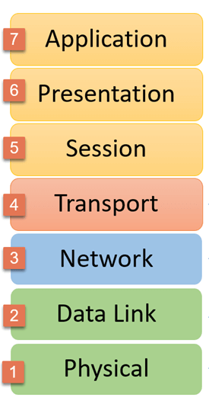

- Relate the devices in the figure below, except Cloud 0, to the 5-layer TCP/IP model. (3 marks)

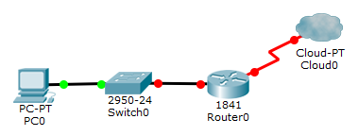

- There are three router ports in the following figure: (i) GE, (ii) AUX, and (iii) Console. Explain their functions. (6 marks)

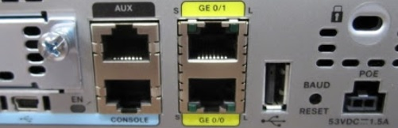

Q1. (Continued)

- The following figure illustrates a typical home network in Malaysia.

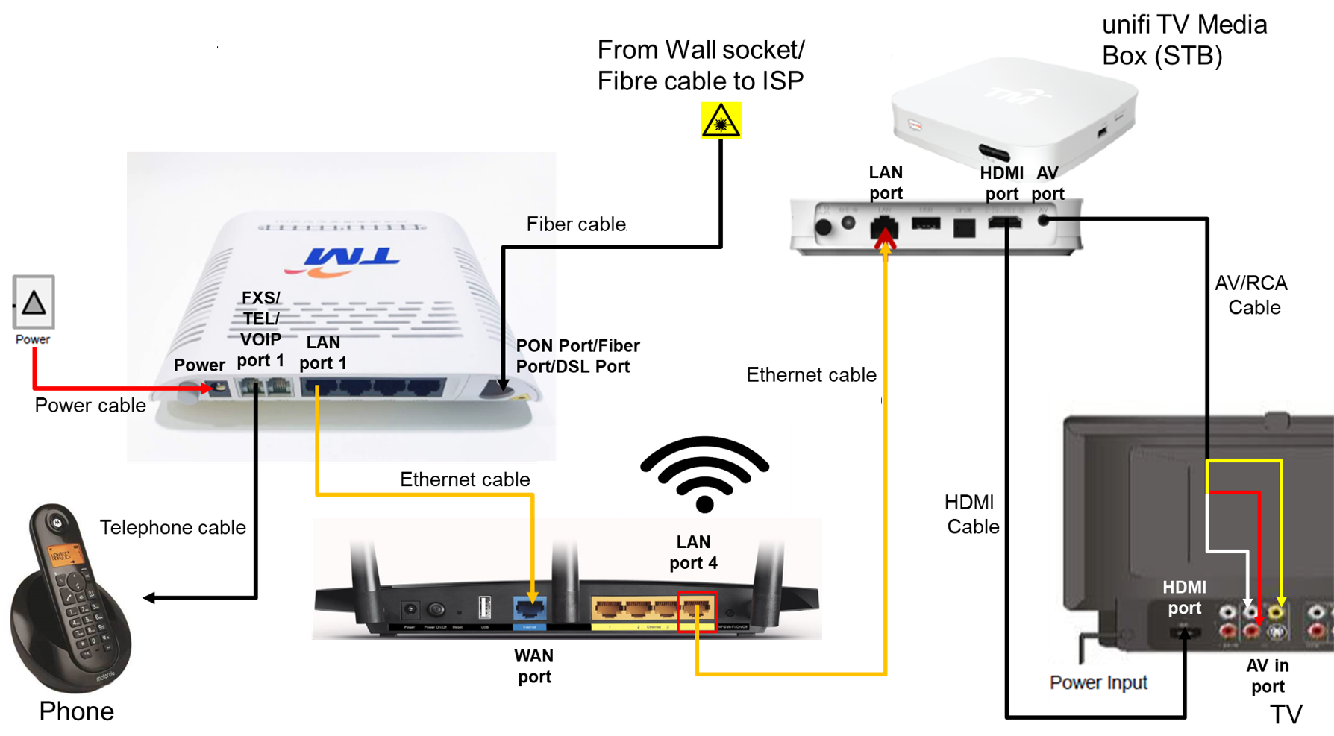

- Name the connector used for Ethernet cable and telephone cable.
(2 marks)

- Give TWO (2) examples of wireless frequency that can be provided by the wireless router. Ali want to have a better Internet speed for his PC. Tell him the wireless frequency he should choose and why. (4 marks)

- State TWO (2) advantages of using fiber cable over Ethernet cable. (4 marks)

- Name the application layer protocol used by the phone for voice communication. (1 mark)
[Total : 25 marks]

Q2. (a) You are given a class A network address of 88.0.0.0.

- State the default network mask for a Class A network. Write them in binary and CIDR notation. (2 marks)

- Explain why a Class A network is too big for an organisation. (2 marks)
- Using only subnet mask, create a minimum of 21 networks and each of them will have a maximum of 254 hosts. Show your steps. (4 marks)

(b) Subnet the Class C IP Address 168.8.8.0 so that you have several subnets, each with a maximum of 14 hosts. Produce the first 4 subnet addresses and their common new subnet mask. (10 marks)

- Give TWO (2) advantages of subnetting. (4 marks)

- Write the maximum length of subnet mask that you can possibly apply for subnetting. Justify your answer. (3 marks)
[Total : 25 marks]
Q3. (a) Analyse the figure of the three-way handshake below to answer the questions.

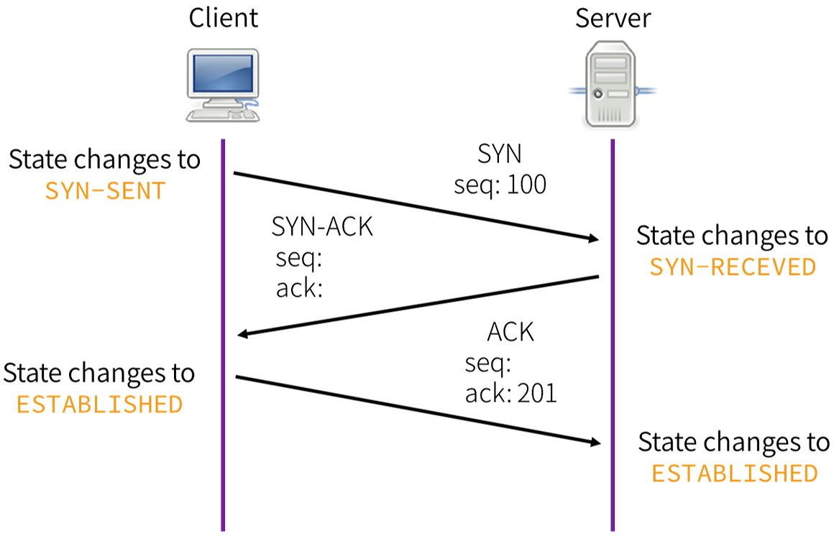
A
B
C

- Explain what client and server is trying to achieve through three-way handshake. (2 marks)

- Explain why acknowledgement is necessary in the process above. (2 marks)

- Explain what happens after Q3 (a) (i) is achieved. (4 marks)

- Write the value for A, B and C. (6 marks)

Q3. (Continued)

(b) Answer the questions by analysing the figure below.

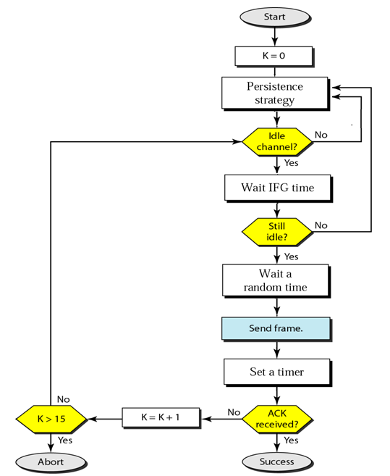

- Explain how this procedure handle collisions. (6 marks)

- Give THREE (3) choices of persistent strategies that can be used in this procedure. (3 marks)

- State the function of K in the figure. (2 marks)
[Total : 25 marks]

Q4. (a) Use the router commands below to answer the questions.

Router(config)# access-list 20 permit 10.10.16.0 0.0.0.255
Router(config)# access-list 20 permit 10.10.17.0 0.0.0.255
Router(config)# access-list 20 permit 10.10.18.0 0.0.0.255
…output omitted…
Router(config)# access-list 20 permit 10.10.31.0 0.0.0.255

- Name the type of ACL used in the commands (1 mark)

- State TWO (2) limitations of using such ACL. (4 marks)

- Write the common subnet mask used by the commands. (2 marks)

- Explain the last statement of this ACL. (2 marks)

- It is inefficient to key in these 16 lines of ACL into the router. Figure out only one line of ACL that can yield the same result. Show your steps to explain your ACL. (4 marks)

(b) Referring to following figures, all the routers are RIP enabled.

- Construct the routing table for R3 using the table format as shown below. (9 marks)

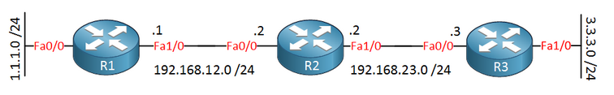

R1# router rip
R1(config-router)# network 192.168.12.0

R2# router rip
R2(config-router)# network 192.168.12.0
R2(config-router)# network 192.168.23.0

R3# router rip
R3(config-router)# network 192.168.23.0
R3(config-router)# network 3.3.3.0

Q4(b). (Continued)

The routing table R3

C or O | Network address | Interface

- Explain which routing protocol a router will choose when both RIP and OSPF are enabled in a router. (3 marks)
[Total : 25 marks]

_______________________________

